Academic Year: 2025-26 | Year: Second Year | Semester: II
PRN No.: 1012411011 | Name: Riddhee Kulkarni
Subject: Python Programming
Assignment No.: 2
Date: 22/12/2025

Lab Assignment: 02
Aim:
To write a Python program to enter a number and display its hexadecimal equivalent, octal equivalent, and square root.

Objective:
- To understand and use Python’s built-in functions for number system conversion.
- To convert a given decimal number into its hexadecimal and octal equivalents.
- To apply the math module for performing mathematical operations like finding the square root.
- To gain practical experience in accepting user input and displaying formatted output in Python.

Theory:
Python provides built-in functions to convert numbers into different number systems.
- hex() converts a decimal number to hexadecimal.
- oct() converts a decimal number to octal.
The math module provides mathematical functions.
- math.sqrt() is used to calculate the square root of a number.
The round() function is used to limit the number of decimal places.

Algorithm:
- Start the program.
- Import the math module.
- Input an integer number from the user.
- Convert the number into hexadecimal using hex().
- Convert the number into octal using oct().
- Find the square root using math.sqrt().
- Display the hexadecimal value, octal value, and square root.
- Stop the program.

Pseudo Code:
START
IMPORT math
READ number
hex_value ← hex(number)
oct_value ← oct(number)
sqrt_value ← sqrt(number)
DISPLAY hex_value
DISPLAY oct_value
DISPLAY sqrt_value (rounded)
END

Code:
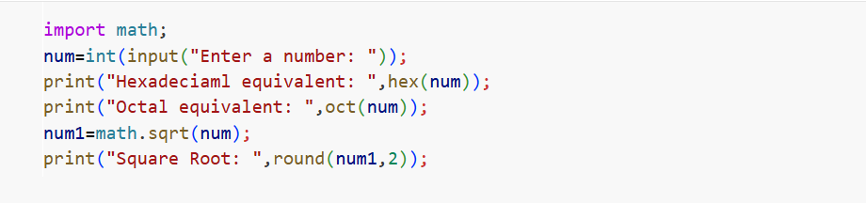

Output:
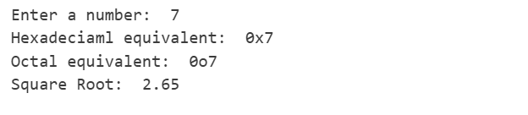

Conclusion:
The program successfully accepts a number from the user and displays its hexadecimal, octal, and square root values using Python’s built-in functions and the math module. This demonstrates number system conversion and mathematical operations in Python.

